OIL-OPERATED SERVO LIQUID CONTROLLER AND COOLING SYSTEM

Operation
Liquid controller

INTRODUCTION

The oil servo was designed to assist the Driver to control the moving electrodes (dippers) of the liquid controller as they move in and out of the electrolyte at a predetermined rate. This ensures a controlled supply of power to the driving motors.
To ensure that the servo and liquid controller operates correctly, you must know and understand the function and purpose of both these units, and be able to maintain them in the correct manner.

In this module we will discuss the following:

Operation

Acceleration
Manual deceleration
Emergency deceleration

Liquid controller

Construction
Operation
Cooling system

OPERATION

The servo on a winder whether AC or DC, is operated from the Driver’s control lever and assist the Driver to control the speed of the winder. It is a hydraulic power pack which controls the liquid controller on a AC winder or on a DC winder, controls the Ward Leonard face plate (potentiometer) at a preset maximum rate of movement. Fig. 1 illustrates schematically how the servo is connected between the Driver’s control lever and the liquid controller.

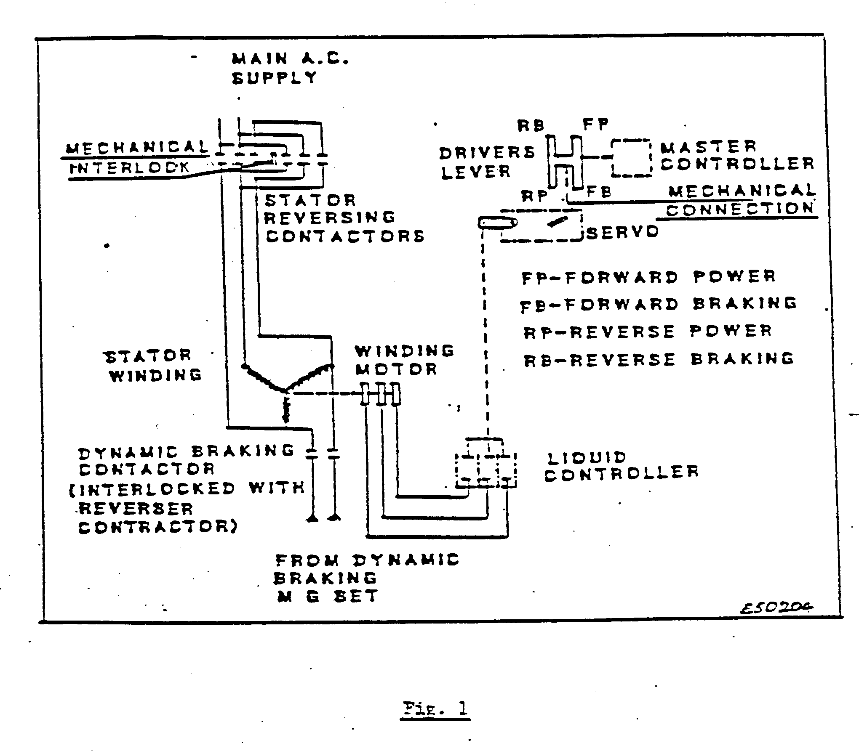
On an AC or DC winder, the servo reacts to the position of the Driver’s control lever to control the speed of the winder. If the Driver moves the control lever to the “full on” position (forward or reverse), the servo will operate the liquid controller from resistance “all in” to resistance “all out” on the AC winder at a preset rate. It will operate the Ward Leonard winder faceplate (potentiometer) on the DC winder to full speed at preset rate.
When the Driver returns the control lever on the AC winder to the neutral position, the liquid controller is rapidly returned to the “full out” position by a counterweight. With the DC winder, when the Driver returns the control lever to neutral, the servo returns the faceplate to neutral at the preset rate.
Both servos operate at a preset rate. This is obtained by an orifice installed in the pipeline, so that the stroke, when actuated by the Driver, gives power at a slower rate than the return stroke.
The speeds for the operation of the servos on both the DC and AC winders are laid down by the winder specifications and legal requirements. In order to determine if a winder is operating safely, it is necessary to have a set of standards as a guide.
The operating times of the servos on the AC and DC winder differ from one another.
The return stroke is when the Driver moves the control lever to the neutral position. The bias weight then pulls the moving electrodes out of the electrolyte.

Fig. 2 illustrates an oil servo-operated controller.

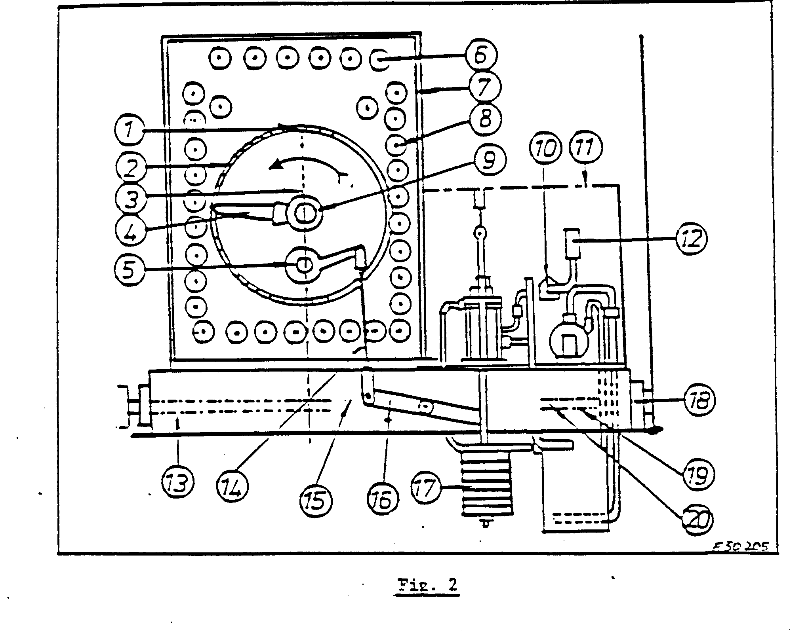
LIST OF COMPONENTS FOR OIL SERVO-OPERATED WARD LEONARD CONTROLLER

DESCRIPTION
Morganite Contact
Face plate Contacts
Face plate operating Arm
Drum finger
Gear Quadrant
Terminal Boards
W.L. controller Case
Resistance units
Internal Drum
Fourways Cock with “T” port
Cover for Servo Gear
Pressure gauge
Bed plate
Connecting Link
Clevis
Driving lever
Bias Weight
Ball Bearings
Operating Shaft
Internal Gear Drive

Acceleration is the time it takes the winder to increase speed from 0 m/sec to the required speed, and is achieved when the Driver moves the control lever to the forward or reverse position.

MANUAL DECELERATION

When the Driver moves the control lever into the neutral position on a DC winder, the servo brings the contact arm on the face plate back to neutral at a preset rate and on an AC winder the liquid controller is returned to the full-out position, thus reducing the speed of the winder.

EMERGENCY DECELERATION

This occurs when there is a trip-out of the safety circuit. Then the servo returns the controller to neutral at a faster rate than normal.
The solenoid-operated bypass valve is arranged to give a fast and slow travel of the power piston. With the solenoid de-energized the power piston changes from fast to slow travel at 90% of the full stroke of the piston. With the solenoid energized, the piston changes from fast to slow travel at 40% of the full stroke. Relief valves are fitted near the top and bottom of the power cylinder to relieve the surge pressure of oil due to the sudden stopping of the moving power piston in both directions.
Under winder conditions, the servo times are liable to change. Therefore, heaters are installed in the oil tank to control the temperature of the oil. Low temperatures will cause the times to be slower, as the oil is then thicker and will be restricted by the orifices. A dirty oil strainer will also affect the servo times, as it will restrict the flow of oil. It is therefore essential that the oil strainer must be cleaned regularly.
Fig. 4 shows a schematic layout of an oil servo-operating device. The two relief valves and the top and bottom of the power cylinder are illustrated. It also shows the orifices and the components of the oil servo.
The orifices installed in the pipelines are normally 1,5 mm bore, but may be larger or smaller, depending on specifications.
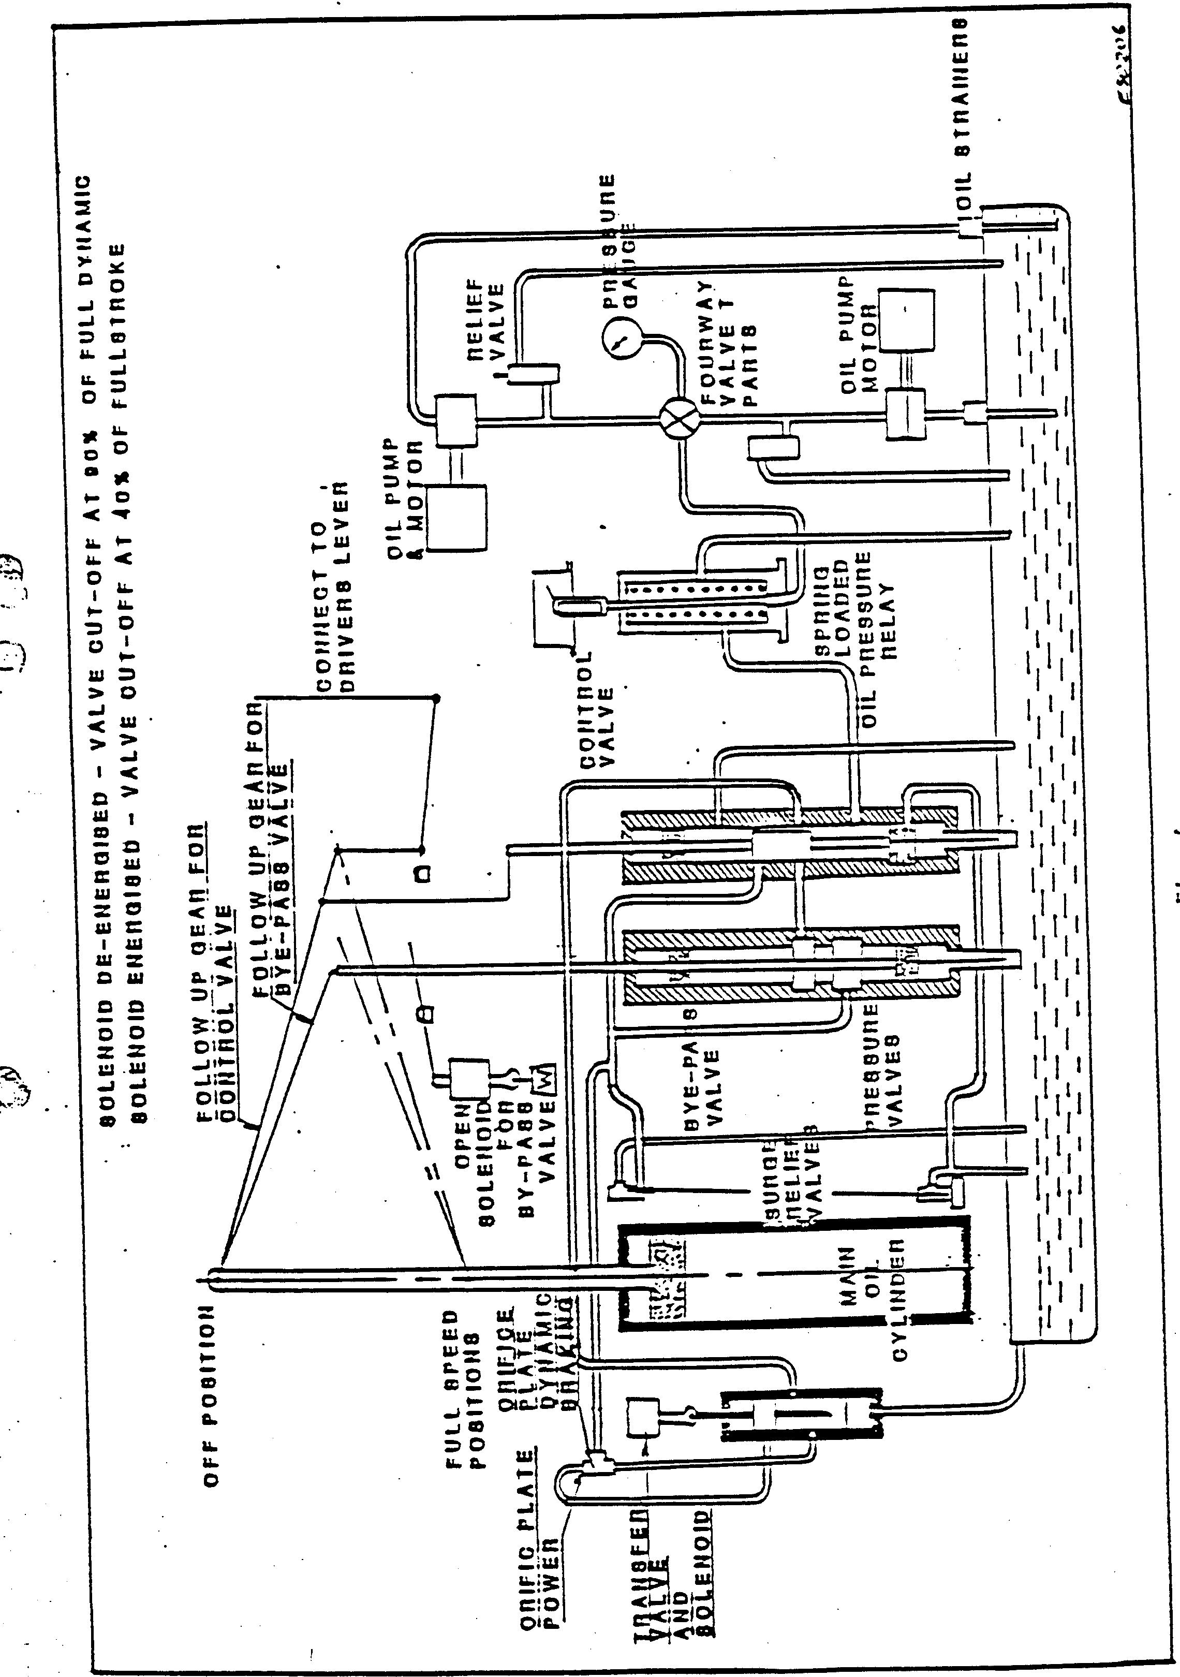

LIQUID CONTROLLER

The liquid controller is directly coupled to the oil servo as described in paragraph 1. The reason being that the components of the controller are heavy and the Driver would not be able to move the moving electrodes without the aid of the servo. The controller is an external variable resistance, connected in the rotor circuit of the winder to control the motor speed.

CONSTRUCTION

The liquid controller consists of three stationary electrodes made of phosphor bronze mounted in three separate vulcanite hard rubber of fibre glass pots, filled with electrolyte (solution) of caustic soda, soda ash or washing soda and clear water. Three moving electrodes, made from a composition of phosphor bronze, are fixed to the ends of copper rods. The other ends of these rods are fixed solidly to a crosshead.

The connections from the rotor slip rings are connected directly to the stationary electrodes. As the moving electrodes are moved deeper into the electrolyte towards the stationary electrodes, the resistance is decreased. This action causes heat to be generated in the electrolyte solution. A cooling system is therefore incorporated in the liquid controller.

Fig. 5 illustrates a typical liquid controller and cooling system.

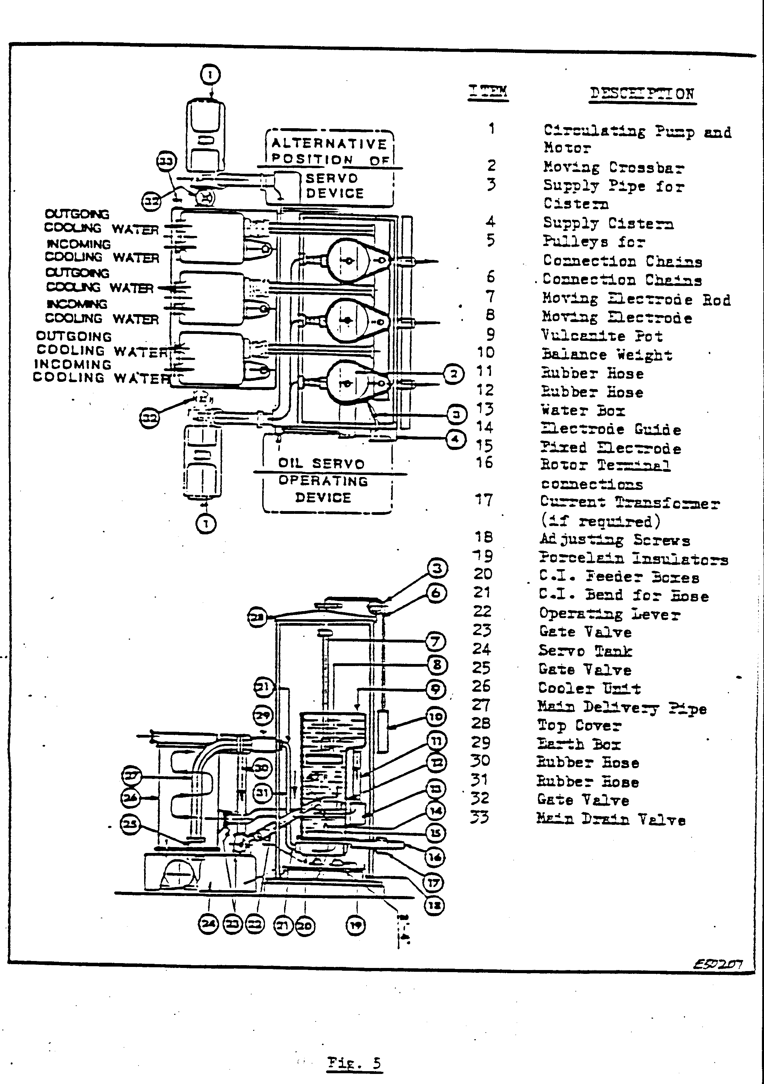
The illustration also shows the two electrolyte pumps. One pump is usually a stand-by.

OPERATION

Before we discuss the operation of the liquid controller in detail, it is essential for you to understand that all the resistance in the rotor circuit is not shorted out, because the moving and stationary electrodes do not touch. If they did, the electrodes would burn.
The liquid controller plays a large role when dynamic braking is used to slow the winder. By applying DC to the winder motor stator, the winder motor is used as a generator driven by the winder, thus dissipating braking energy.

As the Driver moves the control lever further in the dynamic position, until the liquid controller is fully in, the motor will be at creep speed and the brakes can be applied.
When the driver moves the control lever fully in the forward or reverse position, the servo unit operates the moving electrodes of the liquid controller at a set rate to accelerate the winder. In power, the servo time is in the region of + 20 sec. This time could vary on different liquid controllers.
When the control lever is moved to the neutral position, the bias weight pulls the electrodes rapidly out of the solution. The time taken is + 2 to 3 sec.
In Fig. 6, the arrows illustrate the flow of the electrolyte through the system. Orifices are installed in the pipes to control the flow of the solution.

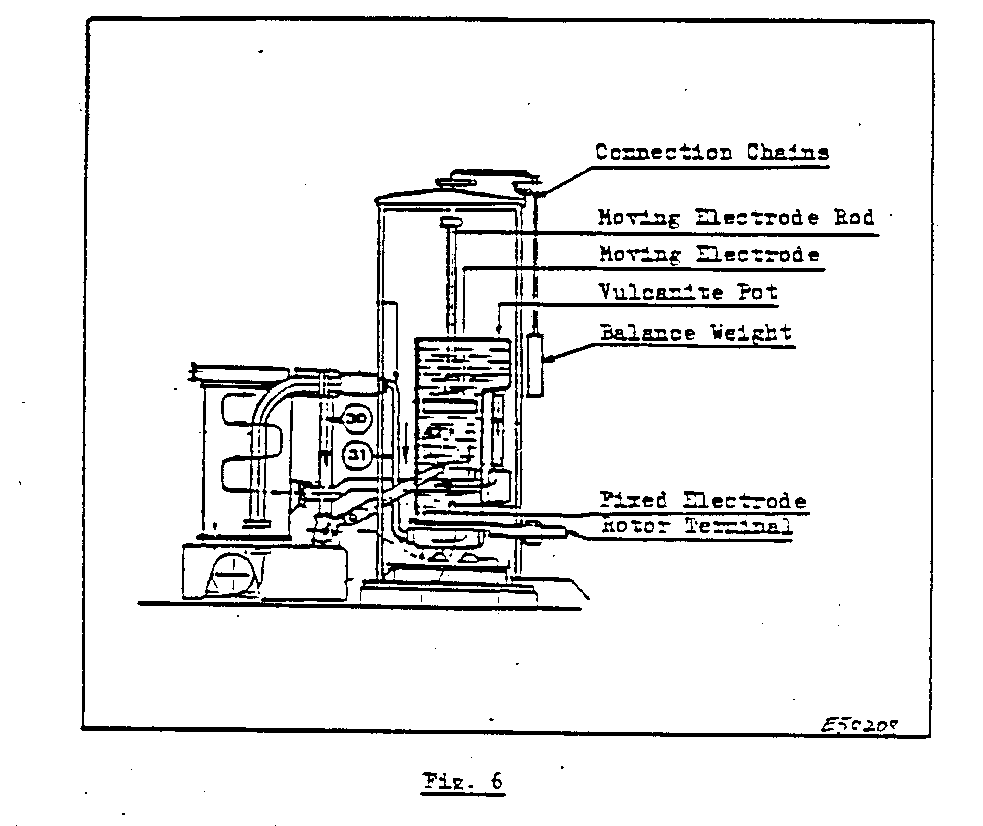
To obtain a good electrolyte solution, the water used must be as pure as possible. The capacity of the controller is + 3 000 to 5 000 litres.
Hard water will increase corrosion and produce scale deposits on the electrodes, these deposits are of an insulating nature, and will reduce the effectiveness of the electrodes. Good commercial washing soda, or as specified, must be used on new installations or after the controller has been drained. The strength of the solution is obtained by trial. Variations occur due to the machine data and different operation requirements.
When adjusting the electrolyte strength, you must note that the resistance of the electrolyte is reduced with increased temperatures. The reduction is + 50% when the temperature is increased from 25 ° C to 70 ° C, which is the maximum temperature.
The electrolyte is automatically topped up with water from a supply line to compensate for evaporation. If you find it necessary to add soda periodically, it is an indication of a leak on either the controller or the cooler.
To prepare the electrolyte, a concentrate of hot water and soda, in small amounts, must be added to the water in each pot. After each addition, circulate the solution until it is properly mixed. Check the “switch on”-current with the electrodes in the “fully out’-position. Continue this procedure until the desired “switch on”-current is obtained.

Losing solution through evaporation is normally caused when the winder has to travel at slow speeds. When doing shaft examination, the solution becomes very hot and will sometimes boil. In this case extra water must be added, which will cause weakening of the solution. Soda must then be added.
If the water level in the pots rises and overflows, it is an indication of a leakage tube in one of the cooling nests. In this case you must arrange to have the cooler isolated and changed during a slack period in the normal shift.
A leaking tube can be temporarily repaired by plugging off both ends. A maximum of ten tubes plugged is allowed on one cooling nest. If more tubes are damaged, the nest must be sent for repairs.

COOLING SYSTEM

The three-cooler unit has a dissipation of 2 100 H.P. (1 567 kW). The initial temperature of the cooling water must not exceed 28 ° C and the final temperature not 70 °C. The maximum flow of water required is 110 litters per sec. The pressure drop across the coolers must not exceed 80 k.p.a.
The cooling system consists of the following components:

- Three cooling nests
- Two cooling pumps
- Two cooling towers
- Top and bottom covers for cooling nests

A spare cooler nest, complete with top and bottom covers, is normally a standard requirement.

In Fig. 7 a typical cooler nest of tubes complete with top and bottom covers is illustrated.

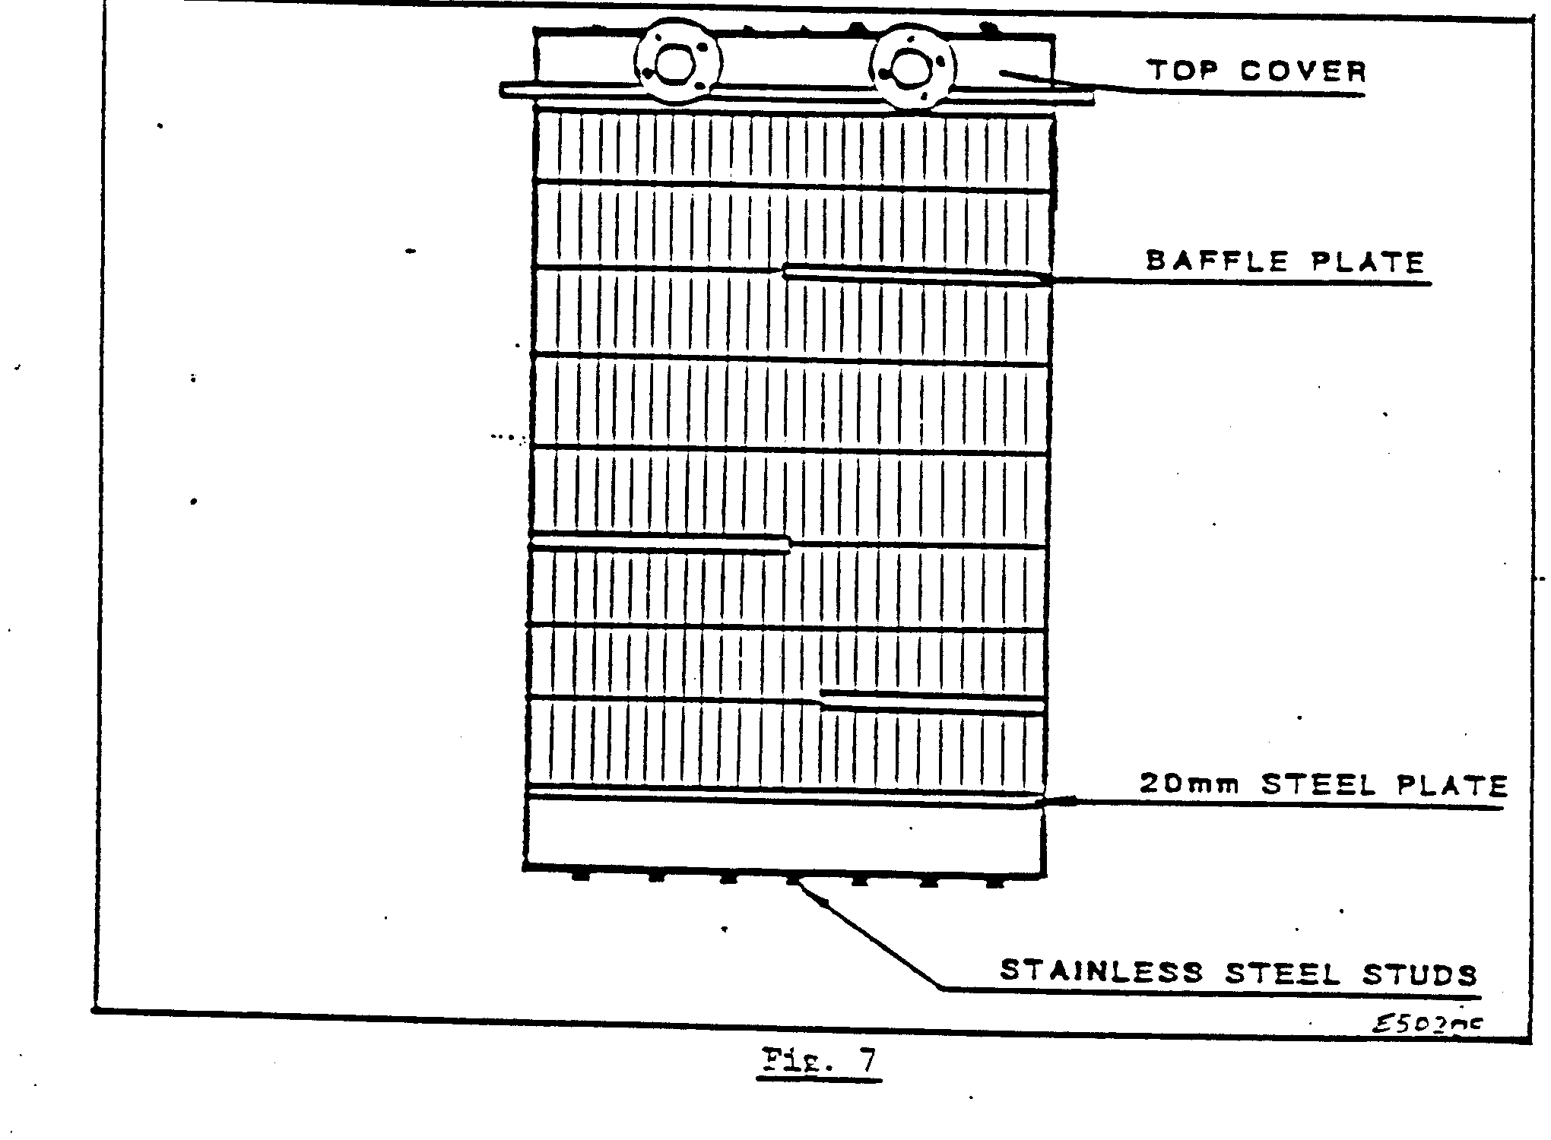
The cooler illustrated in Fig. 7 may consist of seventy tubes. The end plates hold the tubes in position and the tube ends are expanded into the holes in the end plates.
The baffle plates direct the flow of the solution over the whole area of the tubes for cooling. The flow of the cooling water is regulated to 110 litres/sec to allow the solution to cool down as it passes over the tubes.
The old system of cooling ponds and sprays has been changed to a cooling tower system as illustrated in Fig. 8. The cooling tower saves an enormous amount of water as it is enclosed and thus reduces evaporation. The water enters at the tower and falls through filters. A fan situated inside at the top of the tower extracts the heat from the water. Two cooling pumps are situated in the basement. One pump is normally in commission and one on stand-by.
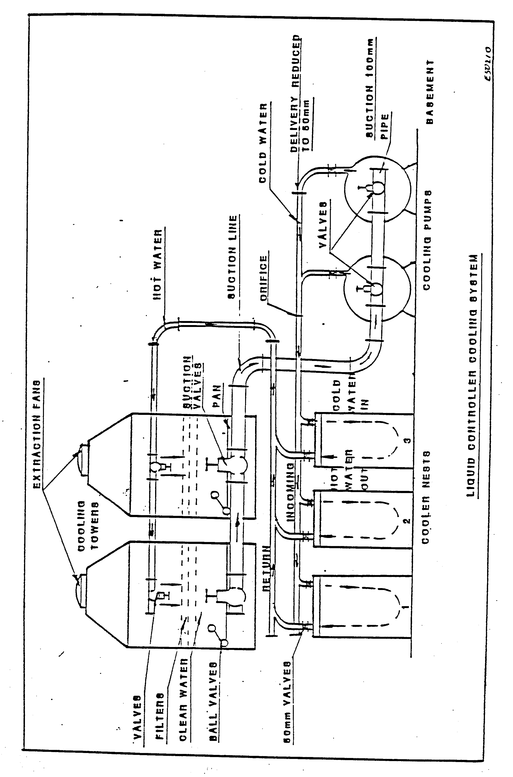
To test for leaks in the tubes, a special pump arrangement is used. This pump has two special fittings. On the pump-side, a special fitting is attached to the pump and on the other side a similar type of plug is screwed into the tube. The tube is then pressurized to 120 k.p.a. If the gauge shows a pressure drop, the tube is leaking. This can be overcome by plugging the tube at both ends with wooden plugs.
The water level in the cooling tower pond is kept constant by a ball valve connected to the clear water line. A water treating chemical is added to the water to prevent corrosion and blockages of the pipes and tubes. The dosage will vary with the water used. Water treatment will be discussed in another module.

